**ULTRASONIC SENSOR(HC-SR04)**

**What is Ultrasonic Sensor?**

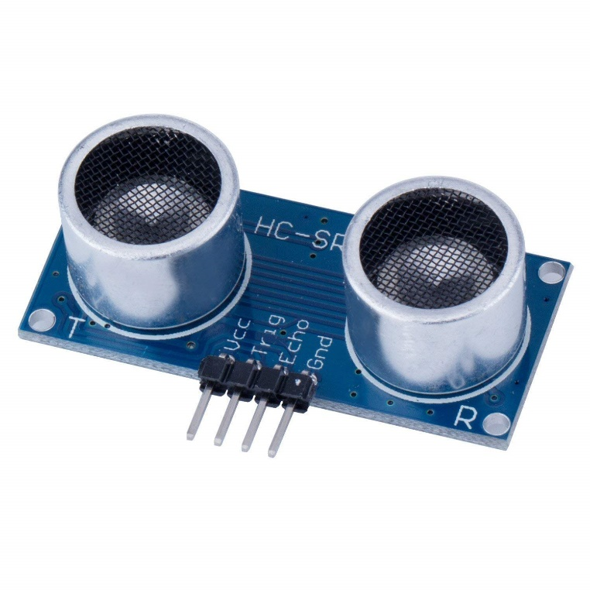Ultrasonic Sensors are the sensors which measures the distance of an object by emitting ultrasonic waves (high frequency sound waves,40kHz to be precise, which are not audible to human ears) then receives the reflected waves from the target object. The inbuilt circuitry will measure the time taken for the ultrasonic waves to return. Using the time, we can obtain the distance using the formula **Distance = (Speed x Time)/2.** Here, the speed is the speed of the ultrasonic waves which is equal to 343 m/s and time is obtained from the sensor. The whole is divided by 2 because the time obtained is time required for the wave to travel from the sensor to the object and back to the sensor.

**How does Ultrasonic Sensor work?**

When the Trigger Pin is set high for 10us, the module will send out an 8 cycle burst of ultrasound at 40 kHz and raise its echo to receive the reflected waves. The Echo pin has a timeout of 38µs, if the reflected signal is not received within 38µs, the Echo pin will return low, indicating absence of any obstacle in its range but if the signal is received with 38µs, then Echo pin returns a pulse with width varying from 150 µS to 25 mS proportional to the time taken to receive the reflected signal.

**Some more Specification**

|  |  |
| --- | --- |
| **Working Voltage** | 5V |
| **Working Current** | 15mA |
| **Working Frequency** | 40 kHz |
| **Max Range** | 4m |
| **Min Range** | 2cm |
| **Measuring Angle** | 15 degrees |

**PINOUTs**

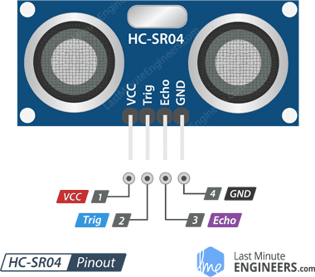

|  |  |  |
| --- | --- | --- |
| **PIN NUMBER** | **PIN NAME** | **PIN DESCRIPTION** |
| 1 | VCC | The supply voltage of 5V is given to this pin. |
| 2 | Trigger | Trigger pin is an Output pin. This pin trigger the ultrasonic sound pulses. |
| 3 | Echo | Echo pin is an Input pin. This pin produces a pulse when the reflected signal is received. The length of pulse is proportional to the time it took for the wave to be detected. |
| 4 | Ground | This pin is connected to Ground. |